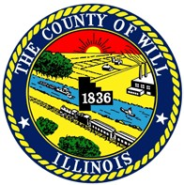Will County’s 2015

WHEN:
Book Recycling Event

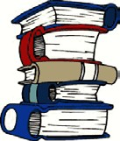June 5th, 6th, 7th Fri – Sun, 9 am to 4:00 pm

WHERE: Joliet Park District’s
Pilcher Park Nature Center
2501 Highland Park Drive, Joliet
DETAILS: Bring your unwanted books for recycling and take books for FREE! Children Books, novels and cookbooks are always desired. There will be NO DOCUMENT SHREDDING this year at this location.

DIRECTIONS: Take Route 30 Cass St. to Highland Park Drive, Pilcher Park.
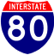Follow signs to Nature Center building.

Highland Park Dr.
NORTH
Nature
Center
Gougar Rd.

Rt. 30 Cass St.
Briggs St.

Event Sponsor: Will County Land Use Department, Resource Recovery and Energy Division
Visit: www.willcountygreen.com or call 815-727-8834 for more info. Location Sponsor: Joliet Park District, Pilcher Park Nature Center

